

Student Name | Gideon kibet Rono
Admission Number | BSCCS/2024/60885
Course | Bachelor of Science in Computer Science
Unit Code | BIT4138
Unit Name | Ethical Hacking and Counter measures
Lecturer | Michael Nyoro
Semester / Year | 2026

Weeks 1 – 5 |

Table of Contents

Contents
Week 1: Network Scanning with Nmap 4
1.1 Tool Installation 4
1.2 KALI linux OS installation 4
Week 2: Network Scanning with Nmap 5
2.1 Open Ports Scan 5
1.2.1 Ports discovered on local host //laragon 6
2.2 Vulnerability Test 6
2.3 Footprinting (OS and Service Detection) 7
2.4 Findings 7
2.5 Student Reflection (Week 1) 7
Week 3: Advanced Nmap Scanning Techniques 8
3.1 Scan Ports 8
3.2 Identify OS Version 10
Results 10
3.3 Detect Running Services 11
3.4 Detect Vulnerabilities 12
3.5 Student Reflection (Week 2) 12
Week 4: Passive OSINT Reconnaissance — Mount Kenya university 13
3.1 Domain and Registra information 13
3.2 DNS Records 14
3.4 Google Dorking 14
3.5 Certificate Transparency 15
3.6 Findings 15
3.7 Analysis 16
3.8 Conclusion 16
Student Reflection (Week 4) 16
Week 5: Vulnerability Assessment of a Web Application 17
Objective 17
Tools used 17
5.1 Network and Service Discovery 17
5.1.1 Objective: 17
5.1.2 Results 17
5.2 Vulnerability Assessment 18
5.2.1 Objective: 18
5.2.2 Findings 18
5.3 Student Reflection (Week 5) 19

Week 1: Network Scanning with Nmap

Tool Installation
Nmap was downloaded from the official website (nmap.org) and installed on a Windows system. The Zenmap graphical interface was installed alongside the command-line version for ease of use.
Installation was completed successfully with output folder configured to C:\Program Files (x86)\Nmap.

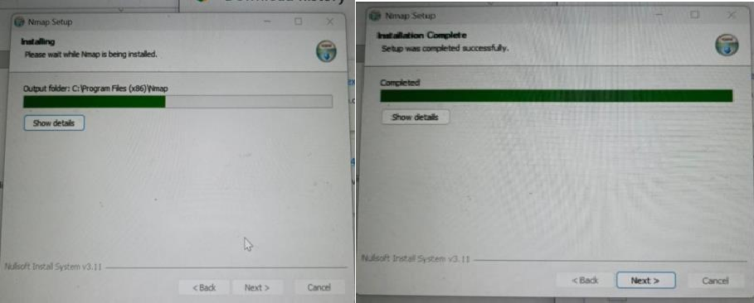

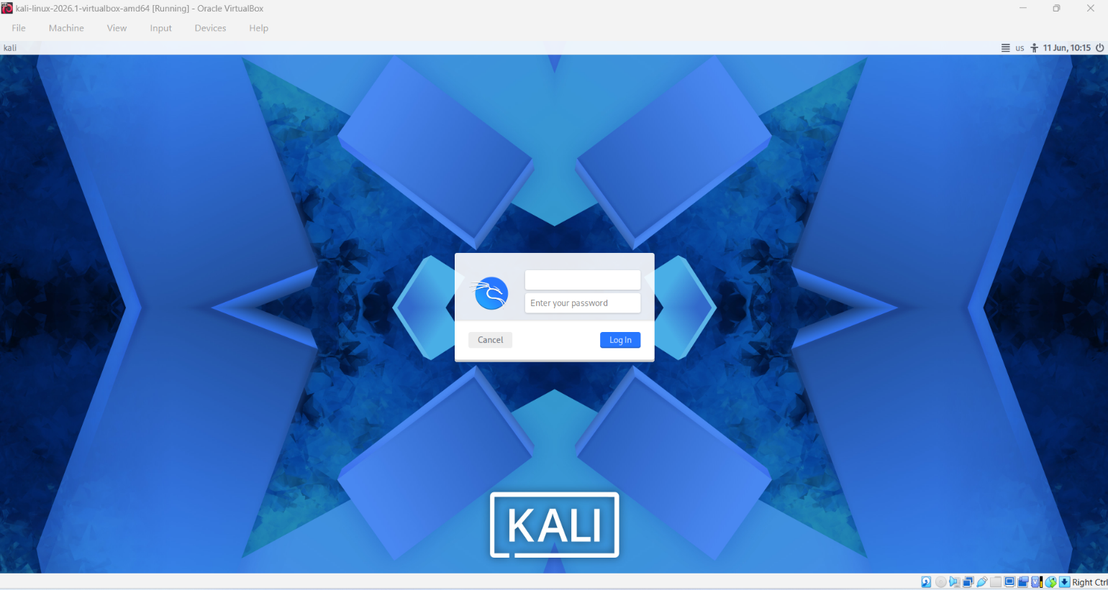
1.2 KALI linux OS installation
Figure 1kali linux OS running on virtual box

Week 2: Network Scanning with Nmap

Open Ports Scan

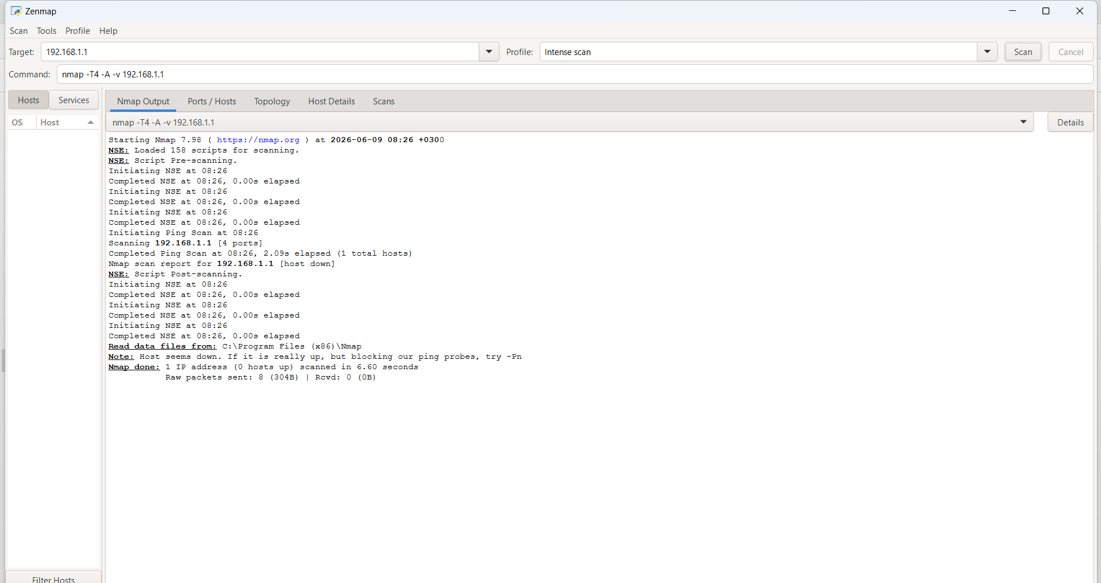
Conducted a full sport scan on my local machine to discover open ports and service running

1.2.1 Ports discovered on local host //laragon

Ports | State | service | version
80/tcp | Open | Apache httpd 2.4.54 | Win open SSL /1.1.1
443/TCP | open | http | Microsoft dns
3306/tcp | open | msql | 8.0.30

Vulnerability Test
A vulnerability scan was performed using Nmap's scripting engine with the command nmap --script vuln 127.0.0.1. This ran known CVE detection scripts against the open ports.

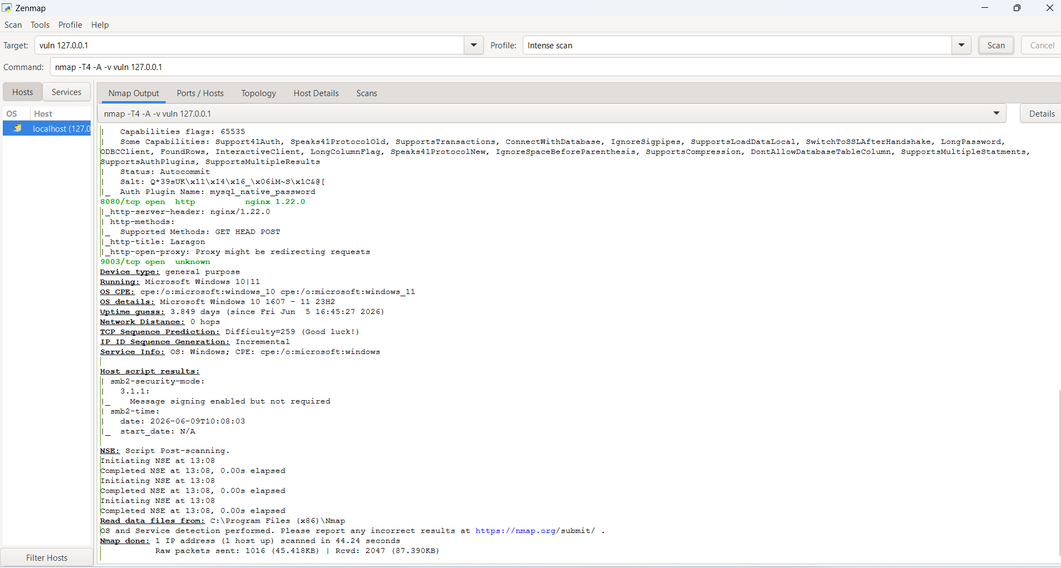

Footprinting (OS and Service Detection)
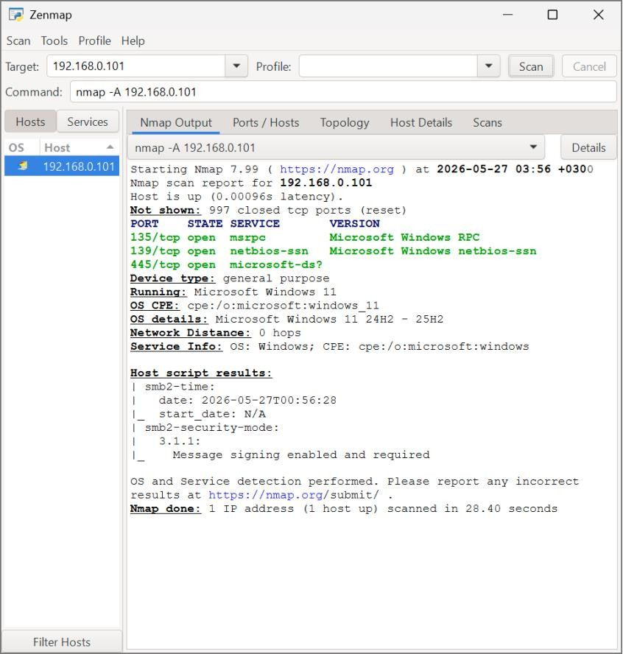
An aggressive scan was run using nmap -A 192.168.0.101 to perform OS detection, service version detection, and script scanning. This scan completed in 28.40 seconds.

2.4 Findings
Device type: general purpose
Running: Microsoft Windows 10|11
OS CPE: cpe:/o:microsoft:windows_10 cpe:/o:microsoft:windows_11
OS details: Microsoft Windows 10 1607 - 11 23H2
Service Info: OS: Windows; CPE: cpe:/o:microsoft:windows

2.5 Student Reflection (Week 1)
During Week 1, I learned how to install and configure Nmap and perform basic network scanning to identify open ports on a target system. I practiced scanning local and remote hosts to detect active services. This exercise helped me understand how port scanning works and its role in network discovery. I also gained awareness of ethical considerations, ensuring scans are only performed on authorized systems. Overall, it built a strong foundation in basic network reconnaissance.

Week 3: Advanced Nmap Scanning Techniques

Tool Used | Nmap (Network Mapper) — Zenmap GUI
Target | - (Local Network Host/ laragon server

3.1 Scan Ports
A targeted port scan was conducted to identify active services running on the host. The scan detected multiple open ports running on local host /laragon host

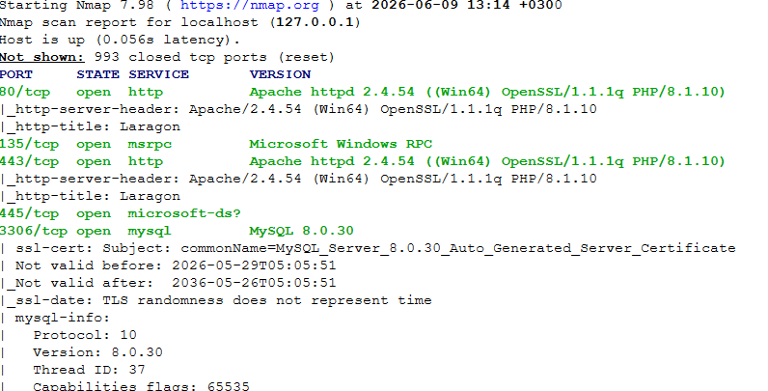

Ports | State | Service
Port 80/tcp | Open | http
For exampe

Identify OS Version

Run nmap -O 192.168.1.1 command on Nmap to discover the type of OS on the target host

Results
Device type | General purpose
OS running | Microsoft windows 11/10
OS OCP | cpe:/o:microsoft:windows_10 cpe:/o:microsoft:windows_11
OS details | Microsoft Windows 10 1607 - 11 23H2

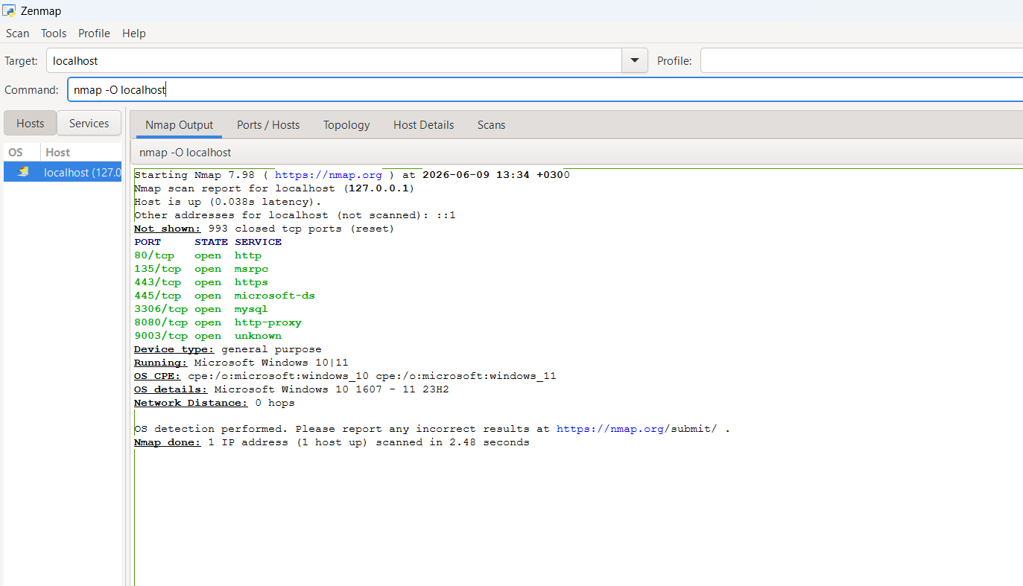

Detect Running Services
Service and version detection (-sV) was performed alongside OS detection. The following services were positively identified on the target host:

Port | Service
80/tcp | http
135//tcp | Msrpc
80800//tcp | http proxy



Detect Vulnerabilities
Vulnerability detection scripts from the Nmap Scripting Engine were executed using nmap --script vuln. Scripts targeted common SMB and Windows vulnerabilities.

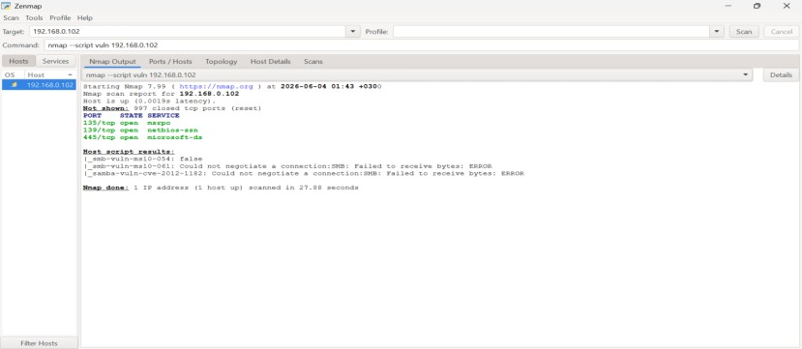

3.5 Student Reflection (Week 2)

During Week 2, I focused on foot printing, OS detection, service identification, and basic vulnerability testing using Nmap. I learned how to gather detailed information about a target system, including operating system type and running services. This helped me understand how attackers and security professionals analyze systems before exploitation or defense. The practical improved my analytical skills and deepened my understanding of network security assessment techniques and reconnaissance stages.

Week 4: Passive OSINT Reconnaissance — Mount Kenya university

Date | June 20 2026
Target Organization | Mount kenya university
Domain | mku.ac.ke
Tools Used | KENIC WHOIS Lookup, Google Dorking, MXToolbox DNS Lookup  crt.sh Certificate Search
Objective | To gather publicly available information about mount kenya university using passive OSINT techniques without directly interacting with its systems.

3.1 Domain and Registra information

Tool Used: KENIC WHOIS Lookup

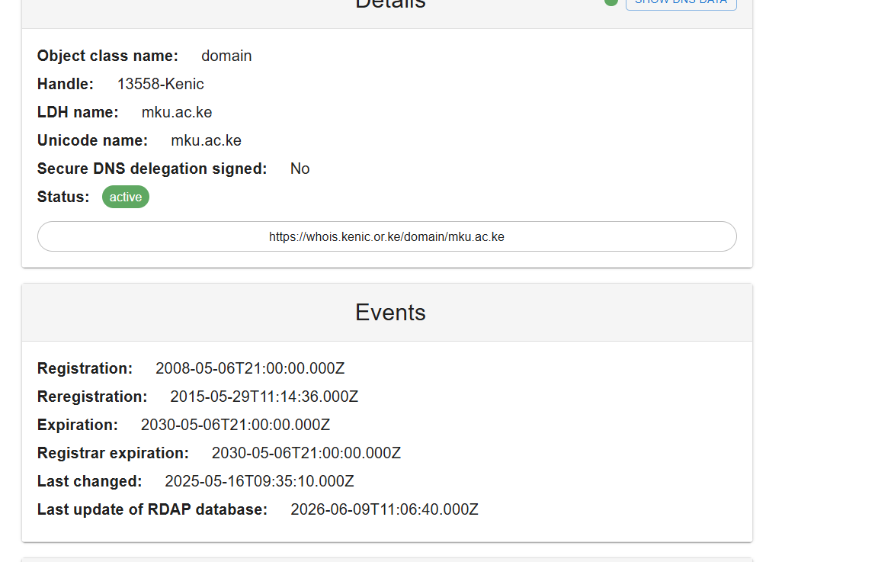

3.2 DNS Records

DiscoveryTool Used: MXToolbox DNS Lookup

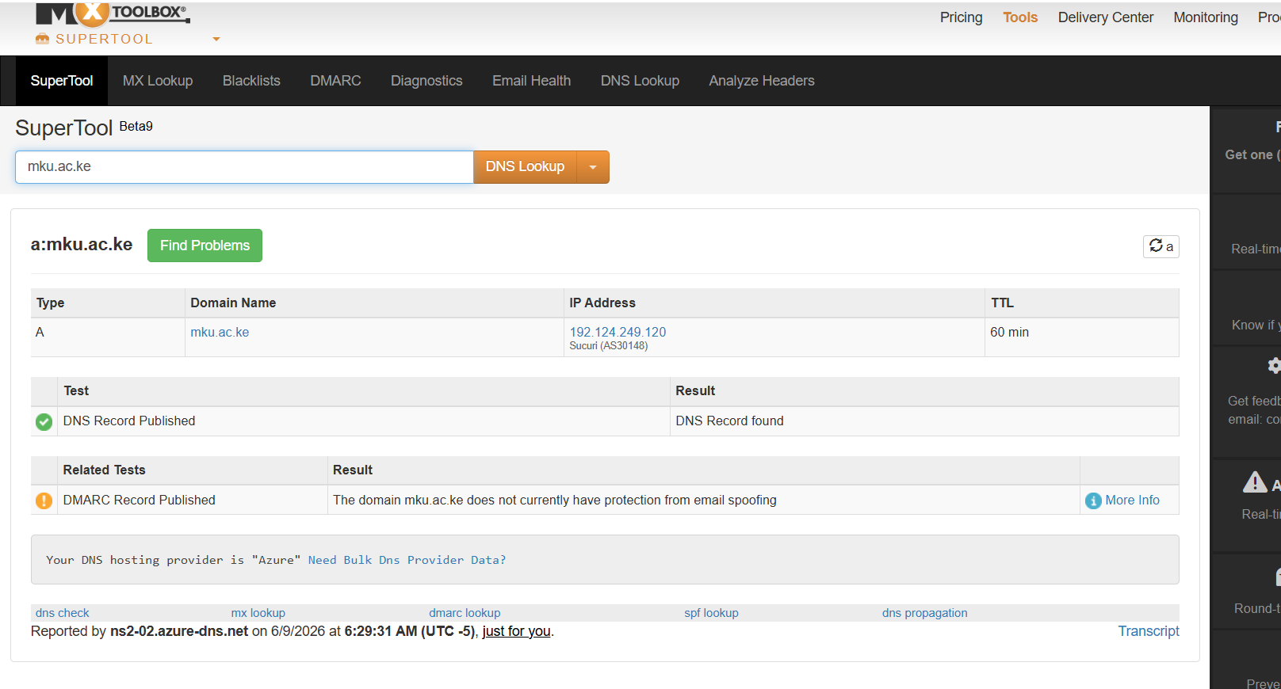

3.4 Google Dorking

Tool used: Google search

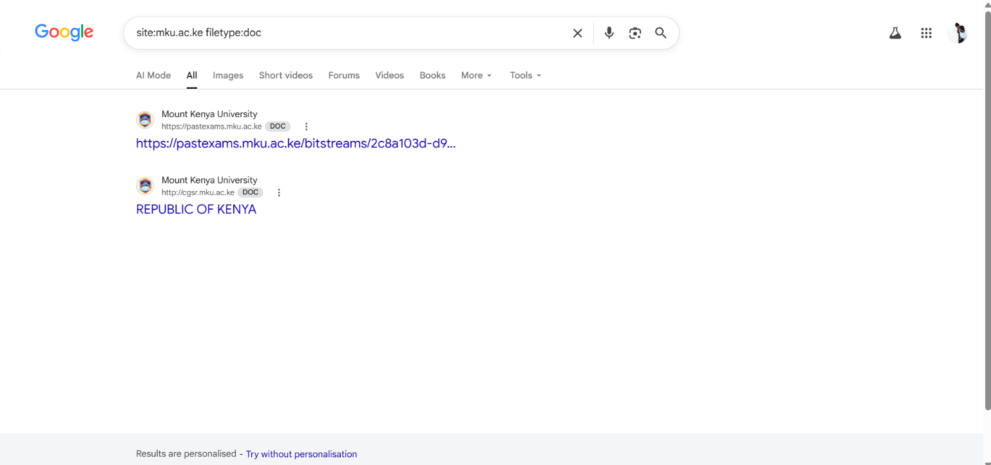

3.5 Certificate Transparency

Tool used :crt.sh Certificate Search

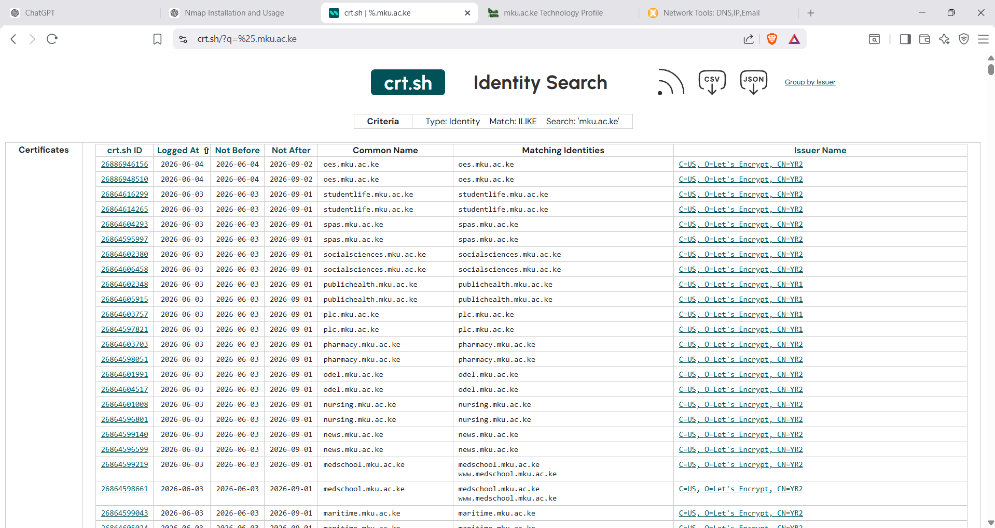

Fig 3.5 List of certificates and subdomains

3.6 Findings

Tool | Information Found
Google Dorks | Public PDFs and university documents
WHOIS | Domain registration details
MXToolbox | DNS records
crt.sh | Publicly visible subdomains

3.7 Analysis
The passive reconnaissance exercise demonstrated that significant information about Mount Kenya University can be obtained from publicly available sources without performing any direct interaction with the university's systems.
The information collected included:
- Public website content
- Domain registration information
- DNS infrastructure
- Website technologies
- Publicly visible subdomains
- Historical website records
This information could assist security analysts in understanding an organization's online presence.

3.8 Conclusion
The passive OSINT reconnaissance exercise on Mount Kenya University was successfully completed using publicly available sources and online OSINT tools.
The investigation revealed useful information about the university's web presence, DNS infrastructure, publicly accessible documents, and technologies used by the organization. No active scanning techniques were employed during this exercise, ensuring that the reconnaissance remained entirely passive.

Student Reflection (Week 4)

During Week 3, I learned how to perform Passive OSINT reconnaissance by collecting information from publicly available sources without directly interacting with the target system. Using tools such as Google Search, WHOIS Lookup, MXToolbox, and BuiltWith, I gathered information about Mount Kenya University’s online presence. This exercise helped me understand the importance of information gathering in cybersecurity and the difference between passive and active reconnaissance techniques.

Week 5: Vulnerability Assessment of a Web Application

Objective
To identify potential security weaknesses in a locally hosted PHP web application using ethical vulnerability assessment techniques and recommend appropriate security controls.

Tools used

- Nmap
- Nikto
- OWASP ZAP

5.1 Network and Service Discovery
Tool Used: Nmap

Command Executed:

nmap -sV 10.7.70.136

5.1.1 Objective:
To identify active network services and technologies supporting the Tsavo Water Delivery System hosted on the local server.

5.1.2 Results

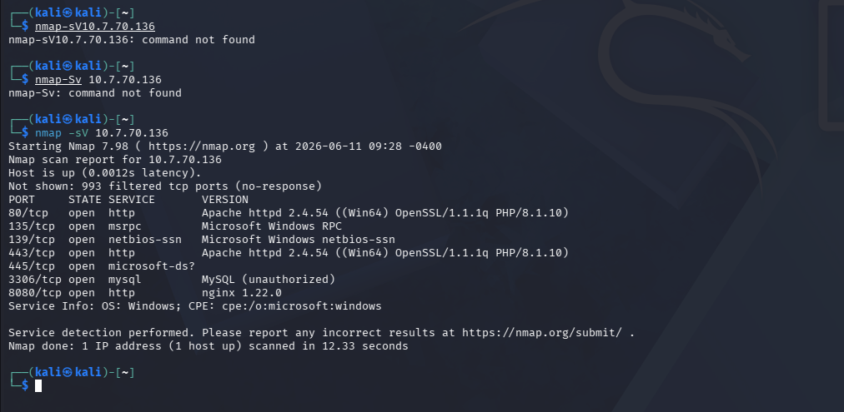

The scan identified seven open TCP ports. The web application was hosted on Apache HTTP Server version 2.4.54 with PHP 8.1.10. MySQL database services were detected on port 3306. Additional Windows networking services including RPC, NetBIOS, and SMB were also identified. An Nginx web server was detected on port 8080.

5.1.3Analysis
The findings confirmed that the application relies on Apache and MySQL services running on a Windows host. The presence of open database and file-sharing services demonstrates the importance of proper network segmentation and access controls. No critical vulnerabilities were identified during this stage; however, exposed services should be regularly monitored and updated to reduce attack surface.

5.2 Vulnerability Assessment

Tool Used:

Nikto Web Server Scanner

Command Executed:
nikto -h http://10.7.70.136

5.2.1 Objective:
To identify common web server vulnerabilities and security misconfigurations affecting the Tsavo Water Delivery System.

5.2.2 Findings

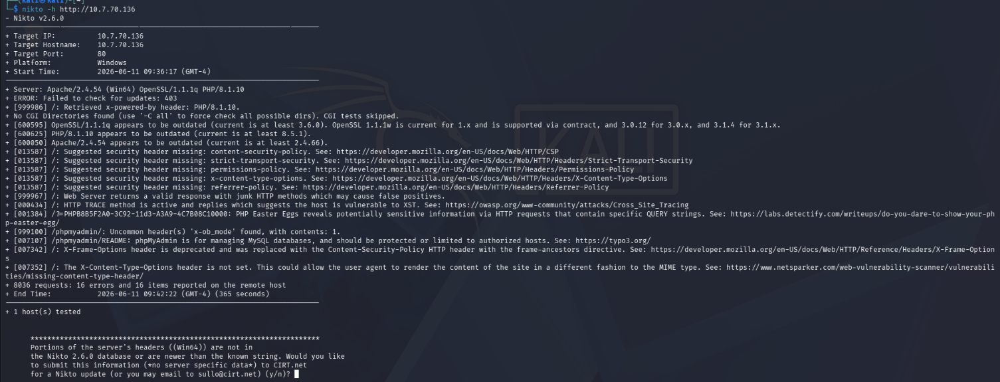

- The web server was running outdated versions of Apache HTTP Server, PHP, and OpenSSL. Outdated software may contain known security vulnerabilities that could be exploited by attackers.
- Multiple recommended HTTP security headers were missing, including Content Security Policy (CSP), Strict Transport Security (HSTS), Referrer Policy, Permissions Policy, and X-Content-Type-Options.
- The HTTP TRACE method was enabled on the server. This method is generally unnecessary and may contribute to information disclosure risks.
- The server disclosed PHP version information through the X-Powered-By response header.
- A phpMyAdmin administration interface was detected, which could become a target for unauthorized access attempts if not properly secured.

5.3 Student Reflection (Week 5)

During Week 4, I performed a vulnerability assessment on a locally hosted web application using Nmap and Nikto. The exercise enabled me to identify active services, outdated software versions, and web server security misconfigurations. I learned how security scanners assist in discovering weaknesses that may expose systems to potential attacks. This practical strengthened my understanding of web application security, vulnerability assessment methodologies, and the importance of implementing security best practices before deploying systems to production environments.

